# Unit – 4 => Servlet: Servlet API, Overview of Servlet, Servlet Life Cycle, HTTP Methods, Attributes in Servlet, Request Dispatcher interface.

# Previous Year Questions (2023)-

1. **Part-A: Define Servlet.**
2. **Part-A: What is API?**
3. **Part-B: Discuss the life cycle of a Servlet.**
4. **Part-B: Discuss features of a Servlet.**
5. **Part-C: Develop a Servlet that handles an HTTP POST request.**

# Previous Year Questions (2022)-

1. **Part-A: Define Servlet life cycle.**
2. **Part-A: What is Servlet and its types?**
3. **Part-B: Explain the life cycle of a Servlet with example.**
4. **Part-B: Explain the following:  
   a. Web Component**

**b. HTTP methods**

# Previous Year Questions (2021)-

1. **Part-A: Define Servlet API?**
2. **Part-A: What do you mean by Attributes in Servlet?**
3. **Part-B: Explain the Servlet life cycle with an example?**
4. **Part-B: Explain the following:  
   a. Web Component**

**b. Overview of Servlet**

## What is Java Servlet?

Java Servlets are the **Java programs** that run on the **Java-enabled web server or application server**. They are used to **handle the request obtained from the web server,** **process the request, produce the response, and then send a response back to the web server**. Java Servlets are also used to **generate dynamic web pages**.

## Properties of Java Servlet

* Servlets work on the **server side**.
* Servlets are capable of **handling complex requests** obtained from the web server.

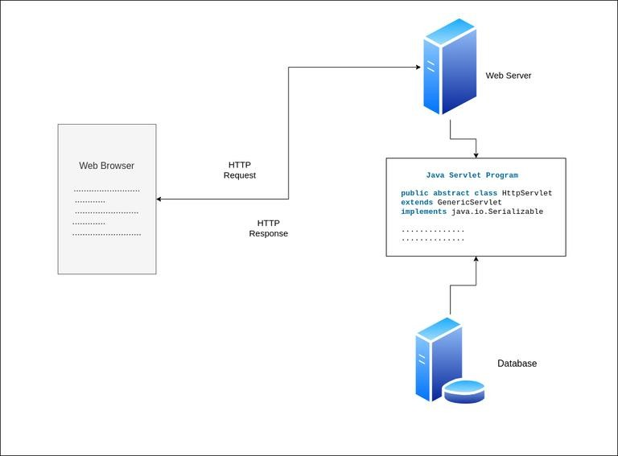

## Java Servlets Architecture

## Execution of Java Servlets

1. The Clients send the request to the Web Server.
2. The Web Server receives the request.
3. The Web Server passes the request to the corresponding servlet.
4. The Servlet processes the request and generates the response in the form of output.
5. The Servlet then sends the response back to the webserver.
6. The Web Server sends the response back to the client and the client browser displays it on the screen.

## Types of Java Servlets :-

**1. Generic Servlet**

* Definition: A GenericServlet is a **protocol-independent base class for servlets**. It is not tied to any specific protocol like HTTP, so it can be used with various protocols (FTP, SMTP, etc.).
* Key Features:
  + It's an abstract class that implements the Servlet interface.
  + Designed for protocol-independent request processing.
  + You need to override the service() method to handle requests.
* Use Case: If you're building a servlet that needs to support other protocols (beyond HTTP), you might extend **GenericServlet**.

**2. HTTP Servlet**

* Definition: An HttpServlet is **a subclass of GenericServlet** and is specifically designed to handle HTTP requests. It provides methods for handling GET, POST, PUT, DELETE, and other HTTP methods.
* Key Features:
  + Most commonly used servlet type for web applications.
  + Provides built-in methods such as doGet(), doPost(), doPut(), etc., that can be overridden for HTTP-specific request handling.
  + Simplifies handling HTTP requests and responses.
* Use Case: Almost all web-based applications use **HttpServlet** to manage interactions between the client (browser) and the server.

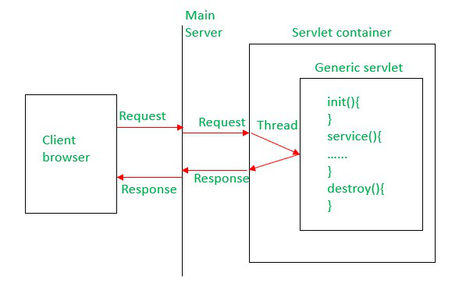 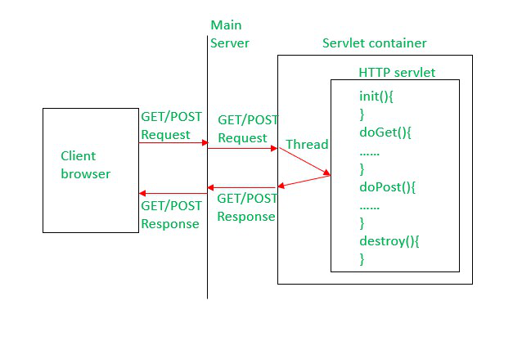

## Advantages of a Java Servlet

* Servlet is **faster than CGI** as it doesn’t involve the creation of a new process for every new request received.
* Servlets are **platform independent** as they are **written in Java**.
* **Removes the overhead of creating a new process** for each request as Servlet doesn’t run in a separate process. There is only a **single instance** that handles all requests concurrently.
* It is a **server-side component**, so Servlet inherits the security provided by the Web server.
* The **API** designed for Java Servlet **automatically acquires the advantages** of the Java platforms such as **platform-independent** and **portability**.
* It can **use the wide range of APIs** created on Java platforms such as **JDBC** to access the database.
* Many Web servers that are suitable for **personal use or low-traffic websites** are offered for free or at extremely cheap costs eg. Java servlet.

## Need of Server-Side Extensions

The Server-Side Extensions are the technologies that are used to create dynamic Web pages. **Web pages** **need a container or Web server** **to provide the facility of dynamic Web pages**. To meet this requirement, independent Web server providers offer some proprietary solutions in the form of **APIs** (Application Programming Interface).

These APIs allow us to build programs that can run with a Web server. In this case, **Java Servlet is also one of the component APIs of Java Platform Enterprise Edition** (nowdays known as – ‘**Jakarta EE**’) which sets standards for creating dynamic Web applications in Java.

# Servlets APIs

The **Servlet API** in Java is a part of the **Java EE (Enterprise Edition) platform** that provides a standard interface for developing server-side components, known as servlets. Servlets are Java programs that run on a web server and handle client requests from web browsers. They enable developers to build dynamic web applications by generating dynamic content, processing input data, and managing session information.

Servlets API has two packages:

* javax.servlet(Basic)
* javax.servlet.http(Advance)

Various classes and interfaces present in these packages are:

|  |  |  |
| --- | --- | --- |
| **Component** | **Type** | **Package** |
| Servlet | Interface | javax.servlet.* |
| ServletRequest | Interface | javax.servlet.* |
| ServletResponse | Interface | javax.servlet.* |
| GenericServlet | Class | javax.servlet.* |
| HttpServlet | Class | javax.servlet.http.* |
| HttpServletRequest | Interface | javax.servlet.http.* |
| HttpServletResponse | Interface | javax.servlet.http.* |
| Filter | Interface | javax.servlet.* |
| ServletConfig | Interface | javax.servlet.* |

## The Servlet Container

Servlet container, also known as **Servlet engine**, is **an integrated set of objects that provide a run time environment for Java Servlet components**. In simple words, **it is a system that manages Java Servlet components on top of the Web server to handle the Web client requests**.

**Services provided by the Servlet container :-**

1. ***Network Services****:* **Loads a Servlet class**. The **loading** may be **from a local file system, a remote file system or other network services**. The **Servlet container provides the network services over which the request and response are sent**.
2. ***Security Services****:* Handles **authorization** and **authentication** of resource access.
3. ***Decode and Encode MIME-based messages****:* **Provides the service of decoding and encoding** MIME-based messages.
4. ***Manage Servlet container****:* **Manages the lifecycle of a Servlet**.
5. ***Resource management****:* Manages the **static and dynamic resources**, such as HTML files, Servlets, and JSP pages.
6. ***Session Management****:* Maintains a session by **appending a session ID to the URL path**.

# 

# Life Cycle of a Servlet

The entire life cycle of a Servlet is **managed** by the **Servlet container** **which uses the javax.servlet.Servlet interface to understand the Servlet object and manage it**.

**Stages of the Servlet Life Cycle** :-

1. Loading a Servlet.
2. Initializing the Servlet.
3. Request handling.
4. Destroying the Servlet.
5. **Loading a Servlet:** The first stage of the Servlet lifecycle involves **loading and instantiating** the Servlet by the Servlet container. The Web container or Servlet Container can load the Servlet at either of the following two stages:
   * Initializing the context, on configuring the Servlet with a zero or positive integer value.
   * If the Servlet is not in preceding stage, it may delay the loading process until the Web container determines that this Servlet is needed to service a request.

The Servlet container performs **two operations** in this stage :

1. **Loading:** Loads the Servlet class.
2. **Instantiation:** Creates an instance of the Servlet. To create a new instance of the Servlet, the container uses the **no-argument constructor**.
3. **Initializing a Servlet:** After the Servlet is instantiated successfully, the Servlet container initializes the instantiated Servlet object. The container initializes the Servlet object by invoking the **Servlet.init(ServletConfig)** method which accepts ServletConfig object reference as parameter.

The Servlet container invokes the **Servlet.init(ServletConfig)** method only once, immediately after the Servlet.init(ServletConfig) object is instantiated successfully. This method is used to **initialize the resources**, such as JDBC datasource.

Now, **if the Servlet fails to initialize**, then it informs the Servlet container by throwing the **ServletException** or **UnavailableException**.

1. **Handling request:** After initialization, the Servlet instance is ready to serve the client requests. The Servlet container performs the following operations when the Servlet instance is located to service a request:
   * It creates the **ServletRequest** and **ServletResponse** objects. In this case, **if this is a HTTP request**, then the Web container creates **HttpServletRequest** and **HttpServletResponse** objects which are subtypes of the ServletRequest and ServletResponse objects respectively.
   * After creating the request and response objects it invokes the **Servlet.service(ServletRequest, ServletResponse)** method **by passing the request and response objects**.

The service() method while processing the request may throw the **ServletException** or **UnavailableException** or **IOException**.

1. **Destroying a Servlet:** When a **Servlet container decides to destroy the Servlet**, it performs the following operations,
   * It allows all the threads currently running in the service method of the Servlet instance to complete their jobs and get released.
   * After currently running threads have completed their jobs, the **Servlet container calls the** **destroy()** **method on the Servlet instance**.

**After the destroy() method is executed**, the Servlet container releases all the references of this Servlet instance so that it becomes eligible for **garbage** **collection**.

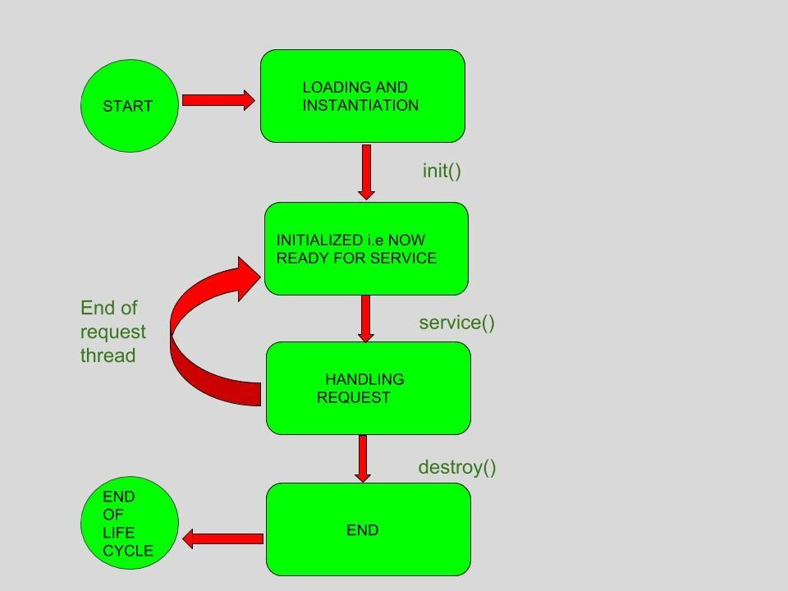

# HTTP Methods

HTTP (Hypertext Transfer Protocol) specifies a collection of request methods to specify what action is to be performed on a particular resource. The **most commonly used** HTTP request methods are **GET, POST, PUT, PATCH, and DELETE**. These are equivalent to the **CRUD** operations (create, read, update, and delete).

**GET:** GET request is **used to read/retrieve data from a web server**. GET returns an HTTP status code of **200** (OK) if the **data is successfully retrieved from the server**.

**POST:** POST request is **used to send data (file, form data, etc.) to the server**. On **success**, it returns an HTTP status code of **201**.

**PUT:** A PUT request is used to **modify** **the data on the server**. It **replaces the entire content** at a particular location with data that is passed in the body payload. **If there are no resources that match the request, it will generate one**.

**PATCH:** PATCH is **similar to PUT request**, but the **only** **difference** is, it **modifies a part of the data**. It will **only replace the content that you want to update**.

**DELETE:** A DELETE request is used to **delete** **the data on the server** at a specified location.

# Attributes in Servlets

An attribute in servlet is **an object that can be set, get or removed by the following aspects**:-

1. **Request Scope**
2. **Application Scope**
3. **Session Scope**

**To pass the value from servlet to html/jsp files**, **setAttribute()** method is called by the request object. setAttribute() method **takes the input as an object which sends the data from servlet to the requesting website**.

**public void setAttribute(String name, Object obj)**

Sets the specified object in the **application scope**.

At the user-end, html uses a syntax by which attributes can be fetched

**${ var-name }**

in which var-name is same as name in **setAttribute()** method

Let’s look at an example of website which validates the form in server side

## HTML File 1 (Requesting Website)

The code will send the input data to the Servlet to process the validation, which in return get the error text if any validation occurs.

## <body>

## <h1>Demo</h1>

## <p style="color: black;">* required field</p>

## <form method="post" action="./CommitServlet">

## <label>Username: *</label>

## 

## <!-- Received response bundle data from the servlet as ${ var-name } -->

## 

## <input type="text" value="${after.inputName}" name="inputName"/>

## <span name="errorName">${errors.Name}</span>

## <br/><br>

## 

## <label>Gender: *</label>

## <input type="radio" name="gender" value="male" />Male

## <input type="radio" name="gender" value="female" />Female

## <input type="radio" name="gender" value="other" />Other

## <span name="errorGender">${errors.Gender}</span>

## <br><br>

## <input type="submit"/>

## </form>

## </body>

## Output:

## HTML1 Output

This Program process the requesting data and checks its validation, if any error encounter it will add the error text in the Bundle known as MAP class. This bundle is again sent to the requesting site for an error correction.

// Servlet code

import java.io.IOException;

import java.util.HashMap;

import java.util.Map;

import java.util.regex.Matcher;

import java.util.regex.Pattern;

import javax.servlet.ServletException;

import javax.servlet.annotation.WebServlet;

import javax.servlet.http.HttpServlet;

import javax.servlet.http.HttpServletRequest;

import javax.servlet.http.HttpServletResponse;

@WebServlet("/CommitServlet")

public class CommitServlet extends HttpServlet {

private static final long serialVersionUID = 1L;

protected void doPost(HttpServletRequest request,

HttpServletResponse response)

throws ServletException, IOException

{

// Create a Bundle of errors in the form of Map

Map<String, String> errors = new HashMap<String, String>();

Map<String, String> after = new HashMap<String, String>();

// Get the input values from the website

String inputName = request.getParameter("inputName");

String inputGender = request.getParameter("gender");

// If error occur, previous entered data will be reflected

after.put("inputName", inputName);

// Check for Validation of Name and Gender

if (!validateName(inputName))

// If error occur, create a entry for

// the bundle and write a alert message

errors.put("Name", "Please enter a valid name");

if (inputGender == null)

// If Gender is not select, encounter an error

errors.put("Gender", "Please select a Gender");

if (errors.isEmpty())

// If no error occur, redirect to the response website

response.sendRedirect("success.html");

else {

// Set this bundle into the request attribute

// and pass the data to the requested website

request.setAttribute("after", after);

request.setAttribute("errors", errors);

request.getRequestDispatcher("comment.jsp").forward(request, response);

}

}

// Method to validate Proper Name, entered by the user

public static boolean validateName(String txt)

{

String regex = "^[a-zA-Z ]+$";

Pattern pattern = Pattern.compile(regex,

Pattern.CASE_INSENSITIVE);

Matcher matcher = pattern.matcher(txt);

return matcher.find();

}

}

**Output :**

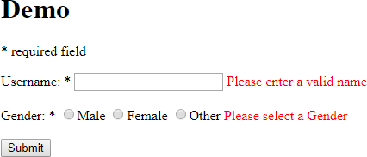

# Servlet – RequestDispatcher

The RequestDispatcher is **an Interface that comes under package javax.servlet**. Using this interface **we get an object in servlet after receiving the request**. Using the RequestDispatcher object we **send a request to other resources** which include (servlet, HTML file, or JSP file). A RequestDispatcher object can be **used to forward a request to the resource or to include the resource in a response. The resource can be dynamic or static**.

**How to Create an Object of RequestDispatcher?**

There are three ways to get an object:-

## RequestDispatcher requestDispatcher = ServletContext.getRequestDispatcher(String path);

*Description:*

* + **public interface ServletContext**. Defines a set of methods that a servlet uses to communicate with its servlet container.
  + path is **a string specifying the pathname to the resource** (servlet, HTML file, or JSP file).

## RequestDispatcher requestDispatcher = ServletContext.getNamedDispatcher(String name);

*Description:*

* + **public interface ServletContext**. Defines a set of methods that a servlet uses to communicate with its servlet container.
  + name is **a string specifying the name of a servlet to wrap**.

## RequestDispatcher requestDispatcher = request.getRequestDispatcher(String path);

*Description:*

* + **request is the HttpServletRequest type object.**
  + path is **a string specifying the pathname to the resource**. If it is relative, it must be relative to the current servlet.

## Method and Description

The class contains two methods:-

## forward

***Syntax:***

void forward(ServletRequest request,ServletResponse response) throws ServletException,IOException

***Description:***

* + Modifier and Type:- void
  + This method is used to forward a request from a servlet to another resource (servlet, JSP file, or HTML file) on the server.
  + The method get called before the response has been sent to the client. If the response is already sent then the method will throws an IllegalStateException.
  + The parameter request(HttpServletRequest type) and response(HttpServletResponse type) are the same objects as were passed to the calling servlet’s service method.
  + This method sets the dispatcher type of the given request to DispatcherType.FORWARD.

## Example:

import java.io.*;

import javax.servlet.*;

import javax.servlet.http.*;

public class GFG extends HttpServlet {

public void doPost(HttpServletRequest request,

HttpServletResponse response)

{

// Perform all the work as per your

// application's architecture

try {

RequestDispatcher requestDispatcher;

// path is a string specifying the pathname to

// the resource. If it is relative, it must be

// relative against the current servlet

requestDispatcher=request.getRequestDispatcher("path");

requestDispatcher.forward(request, response);

}

catch (ServletException servletException) {

}

catch (IOException ioException) {

}

catch (IllegalStateException illegalStateException) {

}

}

}

*Note:* The above code will not run in online IDE this is server-side code.

## include

***Syntax:***

void include(ServletRequest request,ServletResponse response) throws ServletException,IOException

***Description:***

* + Modifier and Type:- void
  + This method is used to include the response of resource(for which the request passed servlet, JSP page, HTML file) in the current servlet response.
  + The parameter request(HttpServletRequest type) and response(HttpServletResponse type) are the same objects as were passed to the calling servlet’s service method.
  + This method sets the dispatcher type of the given request to DispatcherType.INCLUDE.

## Example:

import java.io.*;

import javax.servlet.*;

import javax.servlet.http.*;

public class GFG extends HttpServlet {

public void doPost(HttpServletRequest request,

HttpServletResponse response)

{

// Perform all the work as

// per your application's architecture

try {

RequestDispatcher requestDispatcher;

// path is a string specifying the pathname to

// the resource. If it is relative, it must be

// relative against the current servlet

requestDispatcher=request.getRequestDispatcher("path");

requestDispatcher.include(request, response);

}

catch (ServletException servletException) {

}

catch (IOException ioException) {

}

}

}

*Note:* The above code will not run in online IDE this is server-side code.